MGT 335-Project Management

50pts, Due Sunday @ Midnight

**Assignment #6**

**1-Exercise 1**

1. Draw a Gantt chart using MSP.

See attached file “Assignment #6 EX 1”

1. Assuming a 5‐day week, find the critical path and project duration in days.

Duration is 17 days, critical path is A, C, D, E, G

1. Given that each resource is assigned 100 percent to each task, identify the resource constraints.

X is constrained on B, C, E

1. Using the MSP default, level the resources and determine the new project duration and critical path.

After leveling the new critical path is A, B - C, D, E - F, G and is 22 total days.

1. Identify what alternative solutions can be used to shorten the project duration without over allocating the resources.

A possible alternative is getting more resources or allowing other resources to be on other tasks.

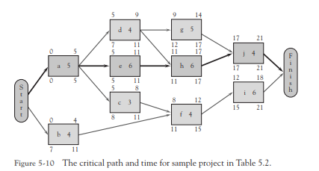

**2-Exercise 4**

1. Minimum slack rule

D

1. Most followers

D

1. Most critical followers

D

1. Shortest task first

C

1. As late as possible

C

**3-Case: Friendly Assisted Living Facility Project Resource Usage -6.**

1. Prepare a Gantt chart with resources for the project plan Dr. Alison submitted. Begin this project on January 3. Prepare a resource calendar for Dr. Alison.
2. How would you handle Dr. Alison's resource problem?

Projects would have to start at different dates so that timing will work. They would all be more spaced out instead of all starting immediately after there predecessor.

1. Given Dr. Alison's availability, how long will it take to complete testing of the assessment tool?

9 days

1. Prepare a Gantt chart for Dr. Alison's plan incorporating any changes you recommend.

See attached file “Assignment #6 CASE”